Use-Case Realization Report
Delete Lesson

Issue <1.0>
Revision History
Date | Issue | Description | Author
<dd/mmm/yy> | <x.x> | <details> | <name>

Table of Contents
1. Brief Description 4
2. Flow of Events 4
3. Interaction Diagrams 4
3.1 Collaboration Diagram for Delete Lesson 4
4. Participating Objects 4
5. Class Diagrams 5
5.1 Class Diagram for Delete Lesson 5
6. Derived Requirements 5

Use-Case Realization Report
Delete Lesson

Brief Description

Flow of Events

Standard Workflows
- Portal Admin selects the lessons to be deleted, click “Delete” button.
- System will validate the lessons to be deleted.
- System will get the list of lessons as well as their sections.
- The selected lessons and sections will be deleted.
- After deletion, the Lesson Page will refresh the lesson list, and show successful message.

Exceptions
If no lesson selected when Portal Admin clicks the “Delete” button, an error message will be displayed on Lesson Page.

Interaction Diagrams

Collaboration Diagram for Delete Lesson
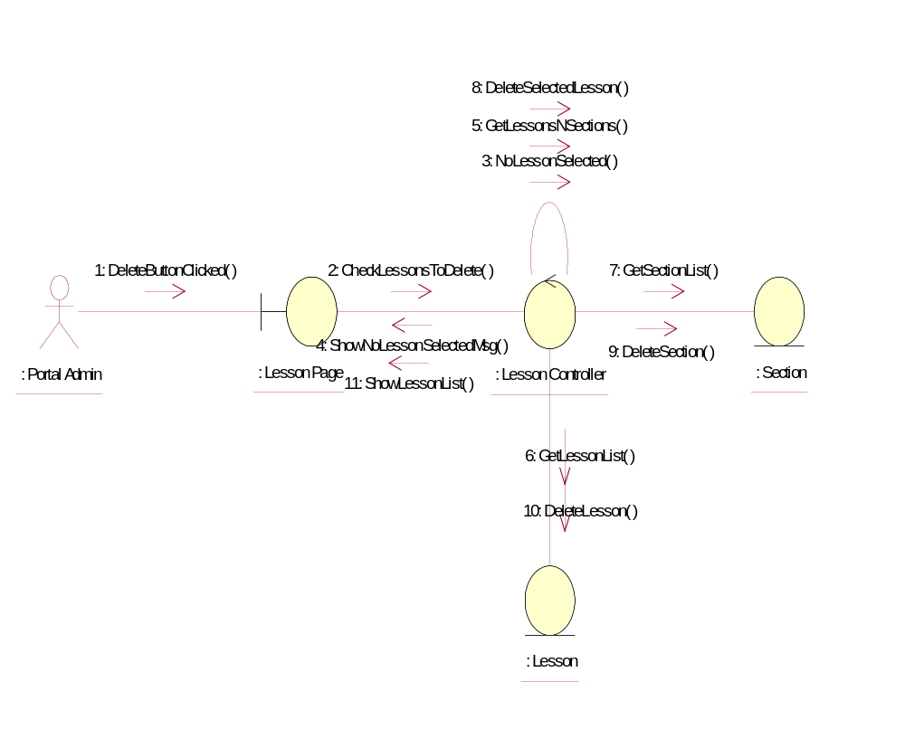

Participating Objects
: Lesson
This entity is the lesson object.
: Lesson Controller
This is the controller to upload, add, delete and modify lessons.
: Lesson Page
This is the page for adding, deleting, modifying lessons.
: Portal Admin
This is the super user of the system.
: Section

Class Diagrams

Class Diagram for Delete Lesson
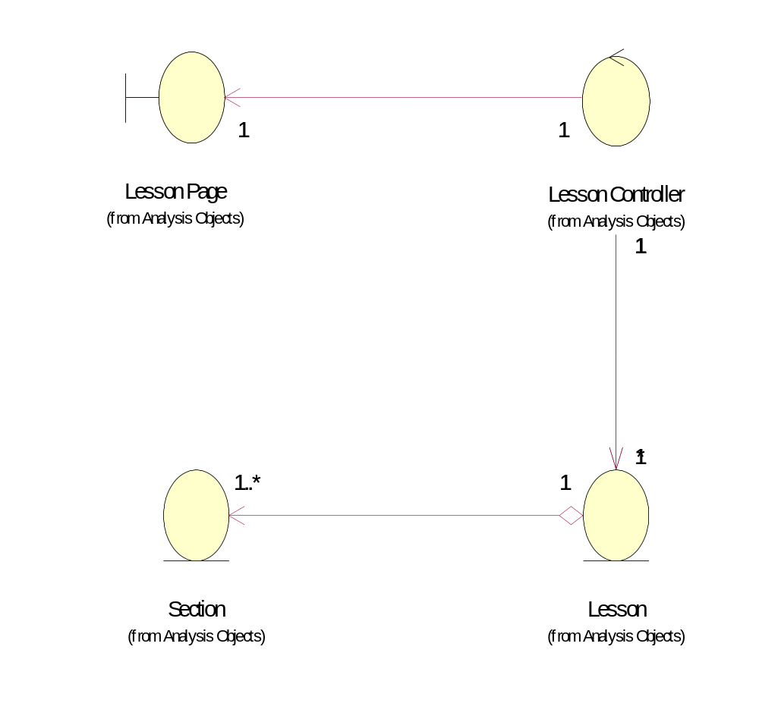

Derived Requirements
Only Portal Admin has access right to this feature.

